Network Security 1 Project Rubric 3

Task: Implement Network Security Fundamentals
Required deliverable: A report documenting:
Requirement | What You Need to Show
1 Firewall Rule | Configure and document one firewall rule, including its purpose, source, destination, protocol/port, action, and result.
1 IDS Configuration | Configure one Intrusion Detection System (IDS) rule/signature and explain what it monitors or detects.
1 IPS Configuration | Configure one Intrusion Prevention System (IPS) rule/signature and explain how it prevents or blocks the activity.
1 Detected Event | Provide one example of an event detected by the IDS/IPS, including what happened, what was detected, and the security response.

Suggested Report Structure
1. Objective
Explain that the purpose of the implementation is to demonstrate basic network security controls through firewall filtering, intrusion detection, and intrusion prevention.
2. Firewall Rule
- Rule name/ID
- Purpose
- Source
- Destination
- Protocol
- Port/service
- Action: Allow/Deny
- Expected result
- Evidence/screenshot
3. IDS Configuration
- IDS name
- Rule/signature
- Traffic being monitored
- Detection criteria
- Expected alert
- Evidence/screenshot
4. IPS Configuration
- IPS name
- Rule/signature
- Traffic being inspected
- Prevention action
- Expected result
- Evidence/screenshot
5. Detected Event
- Date/time
- Source IP
- Destination IP
- Protocol/port
- Event detected
- IDS/IPS alert
- Action taken
- Final result

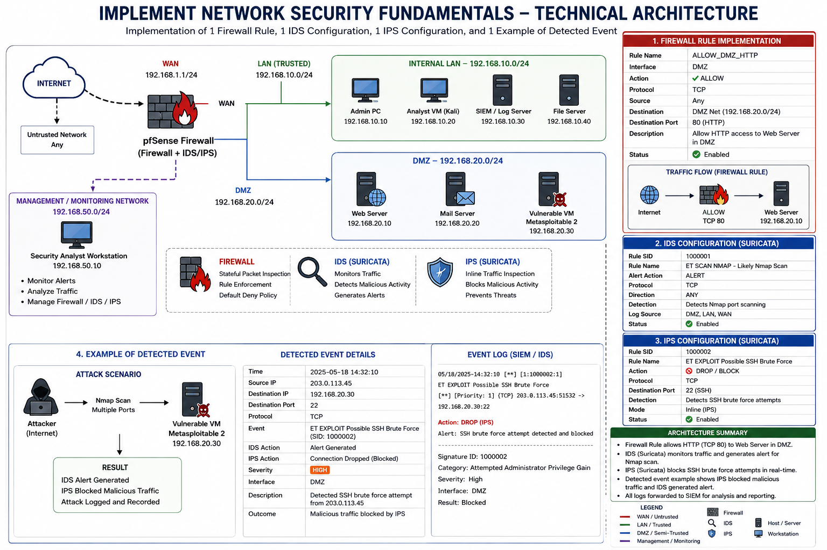
6. Conclusion
Briefly explain how the firewall, IDS, and IPS worked together to protect and monitor the network.
For my cybersecurity lab, this can fit very well with the pfSense/firewall, Kali analyst machine, Metasploitable target, and Wireshark evidence I have been working with.

